Songs from the Heart
Richard Fracker, tenor
Elden Little, piano

Tuesday, September 3, 2019
Cook Recital Hall, 8:00 p.m

Ouvre ton coeur George Bizet (1838–1875)

Gioite al canto mio from Euridice Jacopo Peri (1561–1633)

Col mio sangue comprerei from Il Floridoro Alessandro Stradella (1639–1682)

Chi vuole innamorarsi Alessandro Scarlatti (1660–1725)

Les berceaux Gabriel Fauré (1756–1791)
Lydia
Fleur jetée

Widmung from Myrthen, Op. 25, No. 1 Robert Schumann (1810–1856)

Der Neugierige from Die schöne Müllerin, Op. 25, No. 6 Franz Peter Schubert (1797–1828)

Zueignung from Acht Gedichte aus “Letzte Blätter”, Op. 10, No. 8 Richard Strauss (1864–1949)

Intermission

La vita è inferno all’infelice … O tu che in seno agli angeli from La forza del destino Giuseppe Verdi
(1813–1901)

from Canciones clásicas españolas, Vol. 1 Fernando Obradors (1897–1945)
Al amor
Del cabello más sutil
Coplas de Curro Dulce

Sure on this Shining Night from Four Songs, Op. 13, No. 3 Samuel Barber (1910–1981)

Amazing Grace arr. William Cutter (b. 1956)

Soliloquy John W. Work (1901–1967)

You are my Heart’s Delight from The Land of Smiles Franz Lehár (1870–1948)

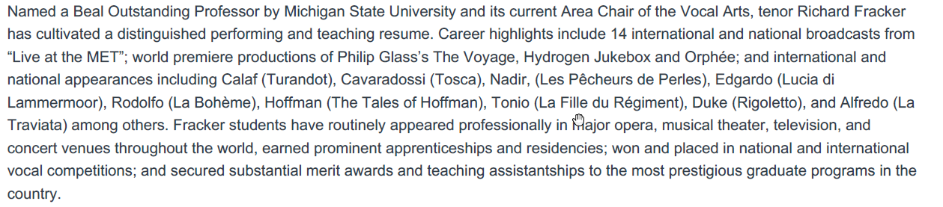

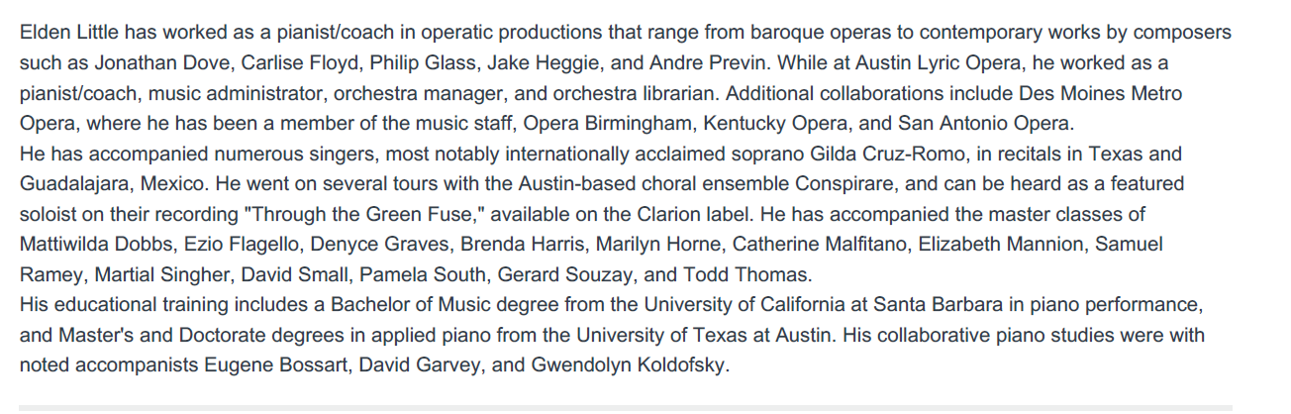

Ouvre ton coeur (Open your heart)
poem by Louis Michel James Lacour Delâtre
La marguerite a fermé sa corolle, | The daisy has closed its petals,
L'ombre a fermé les yeux du jour. | The shadow closed the eyes of the day.
Belle, me tiendras-tu parole? | Beautiful one, will you have a word?
Ouvre ton coeur à mon amour. | Open your heart to my love.
Ouvre ton coeur, ô jeune ange, à ma flamme, | Open your heart, O young angel, to my flame,
Qu'un rêve charme ton sommeil. | May a dream charm your sleep.
Je veux reprendre mon âme, | I want to take back my soul,
Comme une fleur s'ouvre au soleil! | Like a flower opens to the sun!
Gioite al canto mio (Rejoice at my song)
from Euridice, text by Ottavio Rinunccini
Gioite al canto mio selve frondose | Rejoice at my song leafy forests
gioite amati colli, e d'ogni intorno | rejoice beloved hills, and all around
ecco rimbombi dalle valli ascose. | here resounds from the hidden valleys
Risorto è il mio bel sol di raggi adorno, | Risen is my beautiful Euridice in rays adorned,
e co' begl'occhi onde fa scorno a Delo, | and with such beautiful eyes, they surpass Delos,
raddoppia foco all'alme, e luce al giorno, | doubling the flame of souls, and the light of day,
e fa servi d'amor la terra, e 'l cielo | and makes servants to love the earth, and the heavens
Col mio sangue comprerei (With my blood I would buy)
from Il Floridoro, text by Flavio Rosini
Col mio sangue comprerei | With my blood I would buy
quella vita a me sì cara, | the life to me so dear,
s'a una Perdita si amara, | such a loss so bitter
son due fiumi gli occhi miei! | (make) two rivers of my eyes
Chi vuole innamorarsi (Who wants to fall in love)
text by anonymous
Chi vuole innamorarsi, | Who wants to fall in love,
ci deve pensar! | one must well think it over!
Ci dee pensar! | Must think it over!
Amore è un certo foco | Love is a certain type of fire
che, se s'accende un poco, | that if it ignites a little,
eterno suol durar. | forever lasts.
Non è lieve tormento, | Not an easy torment,
aver piagato il cor! | to have a wounded heart!
Soggetta ogni volere | One subjects every want
a due pupille arciere, | to two eyes (of the) archer,
chi serve al dio d'amor. | who serve the god of love.
Widmung (Dedication)
text by Friedrich Rückert
Du meine Seele, du mein Herz, | You my soul, you my heart,
Du meine Wonn’, o du mein Schmerz, | You my joy, you my pain,
Du meine Welt, in der ich lebe, | You my word, in which I live,
Mein Himmel du, darein ich schwebe, | My heaven you, in which I am in it,
O du mein Grab, in das hinab | Oh you my grave, down
Ich ewig meinen Kummer gab! | forever into which I (bury) my sorrow!
Du bist die Ruh, du bist der Frieden, | You are rest, you are peace,
Du bist vom Himmel mir beschieden. | You are heaven to me granted.
Dass du mich liebst, macht mich mir wert, | That you love me, makes me worthy,
Dein Blick hat mich vor mir verklärt, | Your look has me transformed in my sight,
Du hebst mich liebend über mich, | Your love makes me higher,
Mein guter Geist, mein bess’res Ich! | My good spirit, my better self!
Der Neugierige (The curious one)
text by Wilhelm Müller
Ich frage keine Blume, | I ask no flower,
Ich frage keinen Stern, | I ask no star,
Sie können [mir]1 nicht sagen, | none can tell me,
Was ich erführ so gern. | what I would like so much.
Ich bin ja auch kein Gärtner, | Yes I am no gardener,
Die Sterne stehn zu hoch; | the stars are too high;
Mein Bächlein will ich fragen, | my little brook will I ask,
Ob mich mein Herz belog. | whether my heart lied to me.
O Bächlein meiner Liebe, | Oh brook of my love,
Wie bist du heut so stumm? | How are you today so mute?
Will ja nur eines wissen, | I just want one thing to know,
Ein Wörtchen um und um. | One little word whatever it may be.
Ja heißt das eine Wörtchen, | Yes is one little word,
Das andre heißet Nein, | the other is called no,
Die beiden Wörtchen | the two words
Schließen die ganze Welt mir ein. | cover the whole world to me
O Bächlein meiner Liebe, | Oh brooklet of my love,
Was bist du wunderlich! | How are you so quirky!
Will's ja nicht weitersagen, | I will surely not share it,
Sag, Bächlein, liebt sie mich? | Say, brook, does she love me?
Zueignung (Dedication)
text by Hermann von Gilm zu Rosenegg
Ja, du weißt es, teure Seele, | Yes, you know it, dear soul,
Daß ich fern von dir mich quäle, | How away from you I languish,
Liebe macht die Herzen krank, | love makes the heart sick,
Habe Dank. | have thanks.
Einst hielt ich, der Freiheit Zecher, | At one time, I drank to freedom,
Hoch den Amethysten-Becher, | high the amethyst mug,
Und du segnetest den Trank, | and you blessed the drink,
Habe Dank. | have thanks.
Und beschworst darin die Bösen, | And you cast out the evils within it,
Bis ich, was ich nie gewesen, | until I, what I had never been before,
Heilig, heilig an’s Herz dir sank, | blessed, blessed upon your heart I sank,
Habe Dank! | have thanks!
Les Berceaux (The Cradles)
text by René-François Sully-Prudhomme
Le long du Quai, les grands vaisseaux | Along the quay, the big ships,
Que la houle incline en silence | in the swells rock in silence,
Ne prennent pas garde aux berceaux | taking no notice of the cradles,
Que la main des femmes balance | that the hands of women rock.
Mais viendra le jour des adieux | But comes the day of goodbyes,
Car il faut que les femmes pleurent | for the women must cry,
Et que les hommes curieux | and men curious
Tentent les horizons qui leurrent! | aspire to the horizons that lure them!
Et ce jour-là les grands vaisseaux | And on that day the great ships
Fuyant le port qui diminue | leaving the port that fades in the distance,
Sentent leur masse retenue | feels their heft held back
Par l’âme des lointains berceaux | by the soul of the distant cradles
Lydia
text by Charles-Marie-René Leconte de Lisle
Lydia sur tes roses joues | Lydia, on your pink cheeks
Et sur ton col frais et si blanc, | and on your neck, fresh and so white,
Roule étincelant | rols sparkling
L’or fluide que tu dénoues. | the liquid gold that you undo.
Le jour qui luit est le meilleur; | The day that shines is the best;
Oublions l’éternelle tombe. | Let us forget the eternal tomb.
Laisse tes baisers de colombe | Let your dovelike kisses
Chanter sur ta lèvre en fleur. | sing on your lips that bloom.
Un lys caché répand sans cesse | A hidden lily constantly unfolds
Une odeur divine en ton sein; | a bouquet divine (eminates) from your breast.
Les délices comme un essaim, | delights teem,
Sortent de toi, jeune déesse! | come out of you, young goddess!
Je t’aime et meurs, ô mes amours! | I love you and die, oh my love!
Mon âme en baisers m’est ravie! | My soul in your kisses delights!
O Lydia, rends-moi la vie, | Oh Lydia, give me back my life,
Que je puisse mourir, mourir toujours! | that I may die, die over and over again!
Fleur jetée (Discarded flower)
Text by Armand Silvestre
Emporte ma folie | Carry away my folly
Au gré du vent, | as by the wind,
Fleur en chantant cueillie | flower while singing picked
Et jetée en rêvant, | and cast away while dreaming.
- Emporte ma folie | Carry away my folly
Au gré du vent: | as by the wind,
Comme la fleur fauchée | As a flower cut down
Périt l’amour: | love perishes;
La main qui t’a touchée | The hand that touched you
Fuit ma main sans retour. | flees from it without return.
- Comme la fleur fauchée | As a flower cut down
Périt l’amour. | love perishes;
Que le vent qui te sèche | That the wind that dries you out
O pauvre fleur, | poor flower,
Tout à l’heure si fraîche | a short time ago so fresh,
Et demain sans couleur, | and tomorrow pales,
- Que le vent qui te sèche, | That the wind that dries you out
Sèche mon cœur! | dries out my heart!
La vita è inferno all'infelice . . . O tu che in seno agli angeli
(Life is hell to the unfortunate . . . Oh you to the bosom of angels)
from La forza del destino text by Francesco Maria Piave
La vita è inferno all’infelice. | Life is hell to the unfortunate
invano morte desio! | In vain death I desire!
Siviglia! | Seville!
Leonora! | Leonora!
O, rimembranza! Oh, notte | Oh, memories! Oh, night
ch’ogni ben mi rapisti! | of all joy robbed me!
Sarò infelice eternanmente, è scritto. | I will be unhappy forever, it is written.
Della natal sua terra il padre volle | For his native land my father
spezzar l’estranio giogo, | wished to break its foreign yoke,
E coll’unirsi | and uniting himself
all’ultima dell’Incas la corona | with the last of the Incas
cingere confidò. | thought to assume the crown.
Fu vana impresa. | The undertaking was in vain.
In un carcere nacqui; | I was born in a prison;
m’educava il deserto; | educated in the desert;
sol vivo perchè ignota | I live only because unknown
è mia regale stirpe! | is my royal heritage.
I miei parenti | My parents
sognaro un trono, e li destò la scure! | dreamed of a throne, the axe woke them!
Oh, quando fine avran | Oh, when will it end
le mie sventure! | my misfortunes!
O tu che seno agli angeli | Oh you to the bosom of angels
eternamente pura, | forever pure,
salisti bella, incolume | ascendent beauty, unscatched
dalla mortal jattura, | by mortal sorrow,
non iscordar di volgere | do not forget to turn
lo sguardo a me tapino, | your glance down on me, wretched,
che senza nome ed esule, | without name and exiled,
in odio del destino, | hated by fate,
chiedo anelando, | I ask for it,
ahi misero, | miserable,
la morte d’incontrar. | death to encounter.
Leonora mia, soccorrimi, | Leonora mine, help me,
pietà del mio penar! | have pity on my pain!
Pietà di me! | Have pity on me!
Al amor (To love)
text by Cristóbal de Castillejo
Dame, Amor, besos sin cuento | Give me, Love, kisses without count
Asido de mis cabellos | like the hairs grasped by my head
Y mil y ciento tras ellos | and a thousand and hundred after them
Y tras ellos mil y ciento | and after them a thousand and hundred (more).
Y después... | And then . . .
De muchos millares, tres! | to these many thousands, (add) three (thousand)!
Y porque nadie lo sienta | And because there should be no regrets
Desbaratemos la cuenta | let us break the tally
Y... contemos al revés. | and . . . count backwards!
Del cabello más sutil (From your delicate hair)
text by Anonymous
Del cabello más sutil | From your delicate hair
Que tienes en tu trenzado, | that yoou have in your braid,
He de hacer una cadena | I want to make a chain
Para traerte a mi lado. | in order to bring you to my side.
Una alcarraza en tu casa, | A cup in your house
Chiquilla, quisiera ser, | dear girl, I would like to be,
Para besarte en la boca, | In order to kiss you on the mouth,
Cuando fueras a beber. | when you might go to drink.
Ah! | Ah!
Coplas de Curro Dulce (Verses by Curro Dulce)
Text by Francisco Fernández Boigas (Curro Dulce)
Chiquitita la novia, | Petite the bride,
Chiquitito el novio, | Petite the groom,
Chiquitita la sala, | Petite the room,
Y el dormitorio, | and the bedroom,
Por eso yo quiero | For this I want
Chiquitita la cama | a tiny bed
Y el mosquitero. Ah! | and a mosquito net. Ah!

